TASK 3 – TGT_STATE_WISE_SALES.CSV
USE CASE : Regional Sales Analysis
It explains in detail the end-to-end data flow and purpose of each transformation
used in the TGT_STATE_WISE_SALES mapping. The mapping is designed to analyze regional (state-wise) sales performance using cleaned sales transaction data and customer master data.
Overall Objective
The objective of this mapping is to generate a state-wise sales summary report that provides:
- Total number of unique customers per state
- Total number of transactions per state
- Total revenue generated per state
- Average order value per state
This output helps business users understand which states are performing well and where revenue is concentrated.
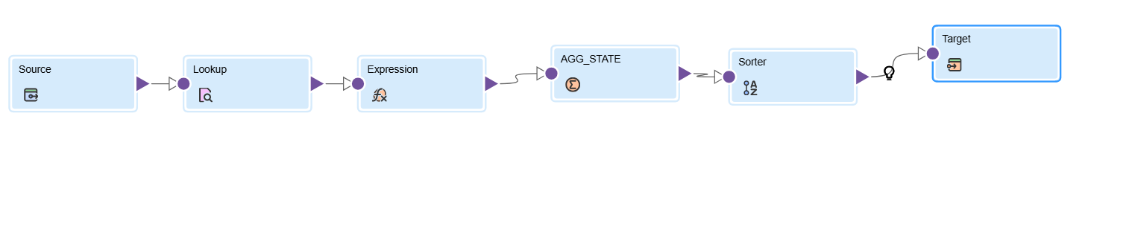
1. Source Transformation
The Source transformation reads data from the flat file Clean_sales_records.csv using a Flat File connection.
This file contains already cleaned and validated transaction data such as:
TRANSACTION_ID, CUSTOMER_ID, PRODUCT_ID, QUANTITY, UNIT_PRICE, DISCOUNT_PERCENT, and TRANSACTION_DATE.
Purpose:
- Acts as the starting point of the mapping.
- Provides transaction-level data for further enrichment and aggregation.
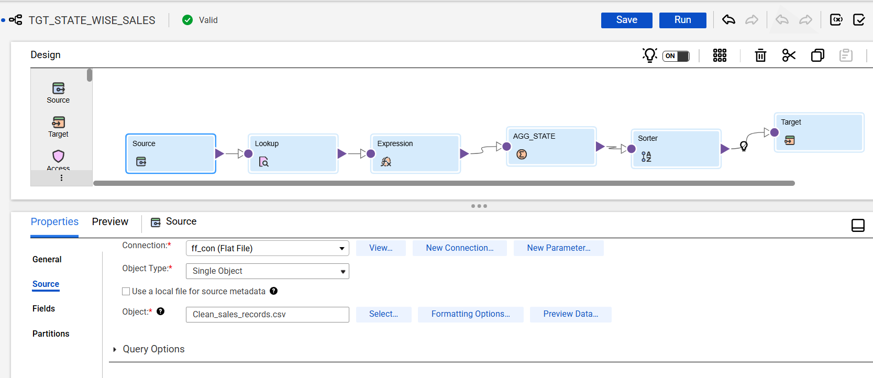
2. Lookup Transformation (Customer Master Lookup)
The Lookup transformation is used to fetch customer-related information from customer_master.csv.
Lookup Condition: CUSTOMER_MASTER.CUSTOMER_ID = INCOMING.CUSTOMER_ID
Returned Field: STATE
Purpose:
- Enrich transaction records with state information.
- Enable regional (state-wise) analysis.
- If no matching customer is found, STATE becomes NULL, indicating a data quality issue.
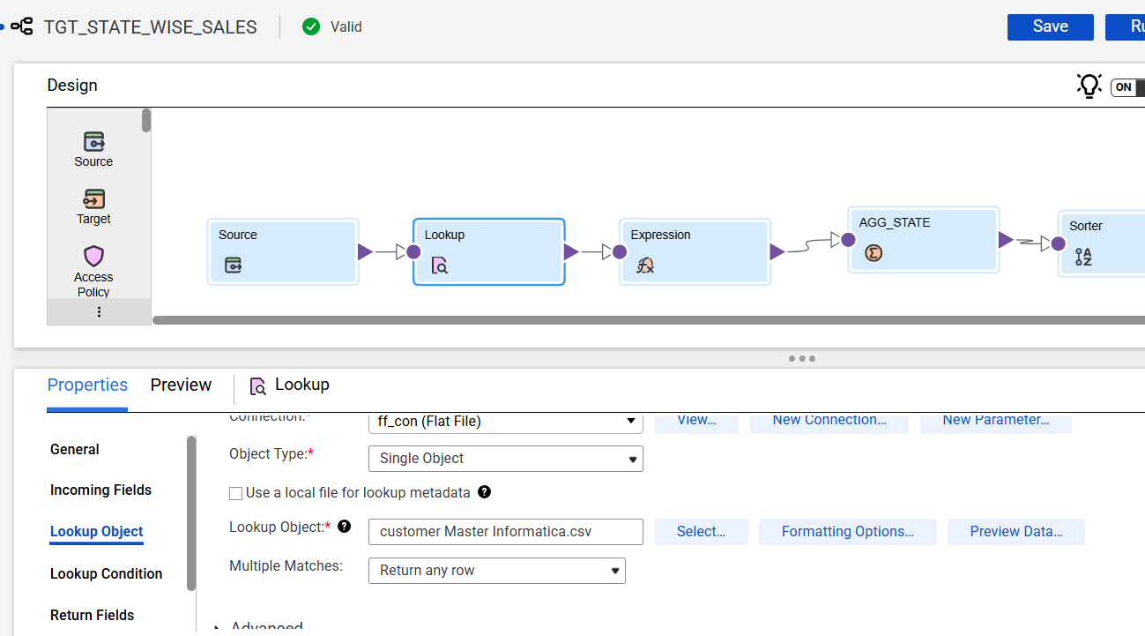
Lookup condition-
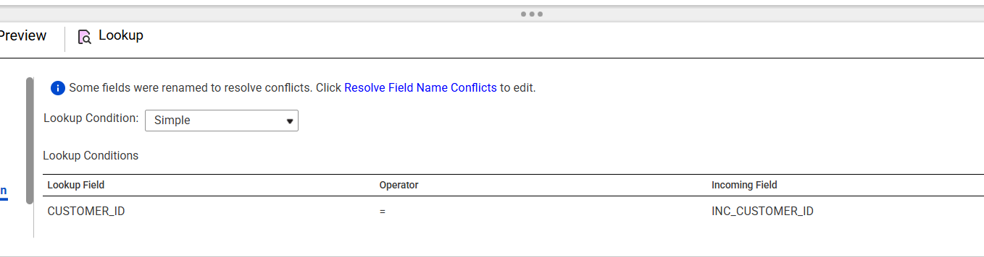
3. Expression Transformation
The Expression transformation performs business calculations required for revenue analysis.
Calculated Fields:
- GROSS_SALES = QUANTITY * UNIT_PRICE
- DISCOUNT_AMOUNT = GROSS_SALES * (DISCOUNT_PERCENT / 100)
- NET_SALES = GROSS_SALES - DISCOUNT_AMOUNT
Purpose:
- Convert raw quantities and prices into monetary values.
- Ensure consistent revenue calculations across all reports.
- Prepare derived measures for aggregation.

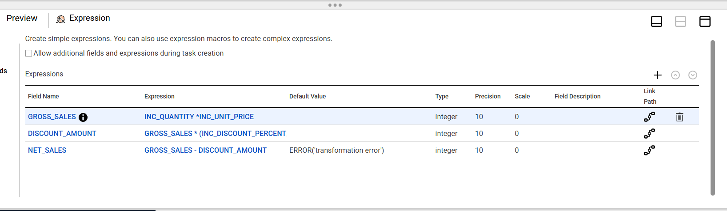
4. Aggregator Transformation (AGG_STATE)
The Aggregator groups records by STATE and calculates summary metrics.
Group By: STATE
Aggregated Metrics:
- TOTAL_CUSTOMERS = COUNT(CUSTOMER_ID) [Distinct enabled]
- TOTAL_TRANSACTIONS = COUNT(TRANSACTION_ID)
- TOTAL_REVENUE = SUM(NET_SALES)
- AVG_ORDER_VALUE = AVG(NET_SALES)
Purpose:
- Summarize transactional data into state-level insights.
- Reduce data volume by aggregating detailed records.
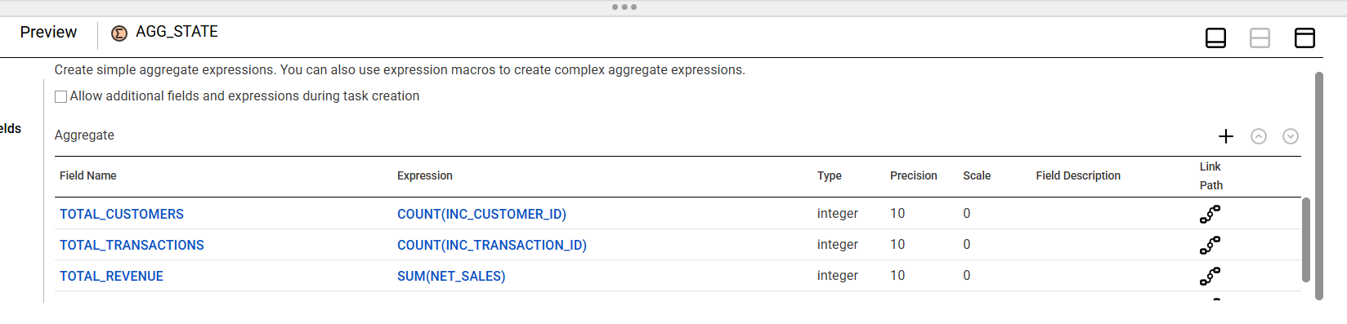
5. Sorter Transformation
The Sorter transformation orders the aggregated records.
Sort Condition: AVG_ORDER_VALUE in Descending order.
Purpose:
- Rank states based on average order value.
- Make it easier to identify top-performing states.
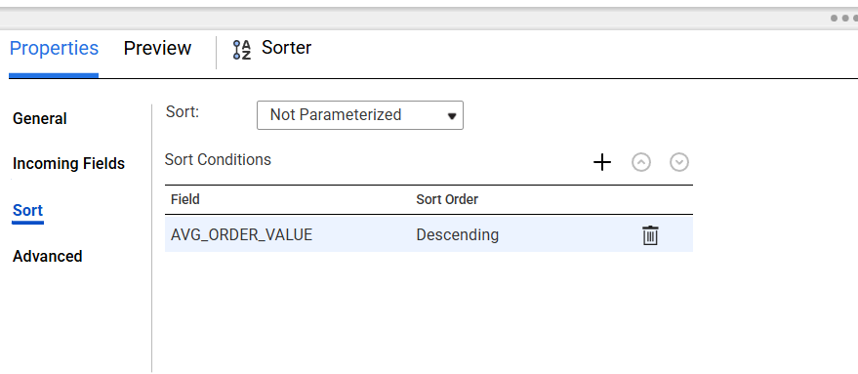
6. Target Transformation (Oracle)
The Target transformation loads data into Oracle table FINAL_TGT_STATE_WISE_SALES.
Operation: Insert
Additional Setting:
Truncate target before load
Purpose:
- Store final regional sales results in database.
- Ensure only latest run data is present in target table.
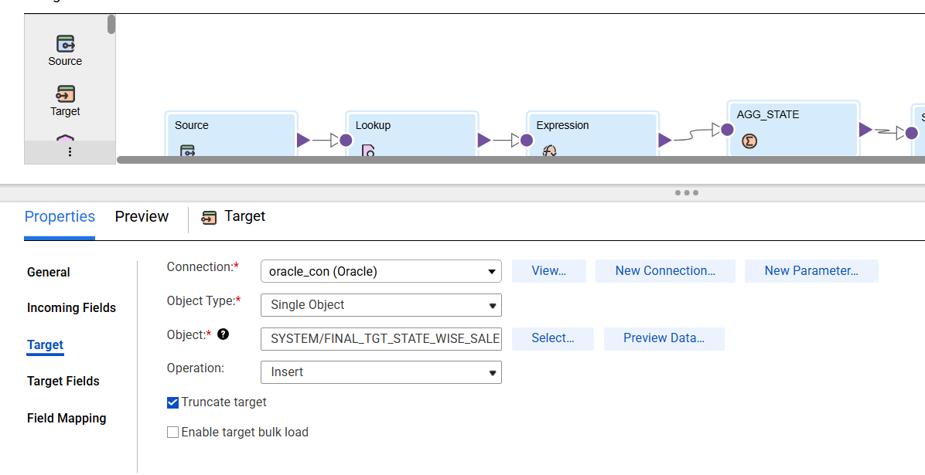
OUTPUT-
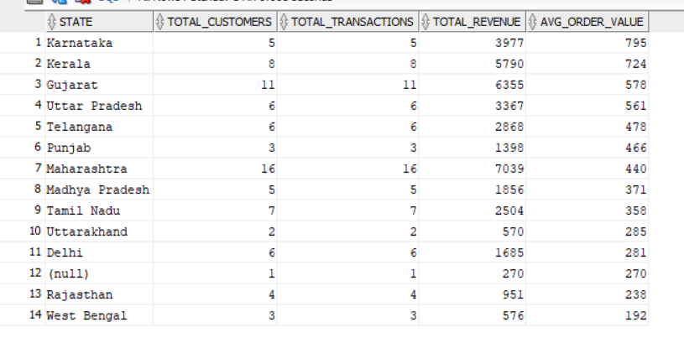
End-to-End Data Flow Summary
Clean Sales File
-> Lookup Customer Master (fetch STATE)
-> Expression (calculate revenue fields)
-> Aggregator (state-wise summary)
-> Sorter (rank states)
-> Oracle Target (final report)
Business Value
This mapping enables business stakeholders to:
- Monitor regional performance.
- Identify high and low performing states.
- Support strategic decisions such as promotions and expansion.

